**Industrial Workers Health and Safety System based on Internet of Things**

**1.INTRODUCTION:**

**1.1 Project Overview:**

The Industrial Workers Health and Safety System based on the Internet of Things (IoT) is a project aimed at improving the safety and well-being of industrial workers by leveraging IoT technologies. This system integrates various sensors, devices, and data analytics to monitor and manage worker health, detect hazardous conditions, and provide real-time alerts and preventive measures.Enhance worker safety: Implement a comprehensive system that continuously monitors the working environment and identifies potential risks and hazards to minimize accidents and injuries.Improve health monitoring: Develop a system that tracks workers' vital signs, such as heart rate, body temperature, and respiratory rate, to identify signs of fatigue, stress, or illness.Real-time alerts and notifications: Enable immediate alerts and notifications to workers and supervisors in case of emergencies, hazardous conditions, or deviations from safe working practices.Data analytics and insights: Collect and analyze data from.

**1.2 Purpose:**

The purpose of the Industrial Workers Health and Safety System based on the Internet of Things (IoT) is to create a comprehensive and proactive approach to ensuring the health and safety of industrial workers. By leveraging IoT technologies, this system aims to address the following purposes: Worker Safety: The system is designed to monitor the working environment in real-time, detect potential hazards, and provide timely alerts to prevent accidents and injuries. By deploying sensors and connected devices, it can monitor factors such as temperature, air quality, noise levels, and presence of toxic gases or chemicals. Health Monitoring: The system collects and analyses data on workers' vital signs and physical conditions, such as heart rate, body temperature, and respiratory rate. This enables early detection of health issues, fatigue, stress, or other factors that may compromise worker safety. By tracking workers' health continuously, the system can provide insights to prevent health-related incidents. Emergency Response: In case of emergencies, such as fire, gas leaks, or equipment failure, the system can quickly identify the location of workers and trigger immediate alerts. This ensures prompt evacuation and provides essential information to emergency response teams for effective rescue operations. Compliance and Risk Management: The system helps organizations maintain compliance with safety regulations and standards.

**2. IDEATION & PROPOSED SOLUTION:**

**2.1 Problem Statement Definition:**

The purpose of the Industrial Workers Health and Safety System based on the Internet of Things (IoT) is to create a comprehensive and proactive approach to ensuring the health and safety of industrial workers. By leveraging IoT technologies, this system aims to address the purposes of Worker Safety, Health Monitoring, Emergency Response, Compliance and Risk Management.

**2.2 Empathy Map Canvas:**

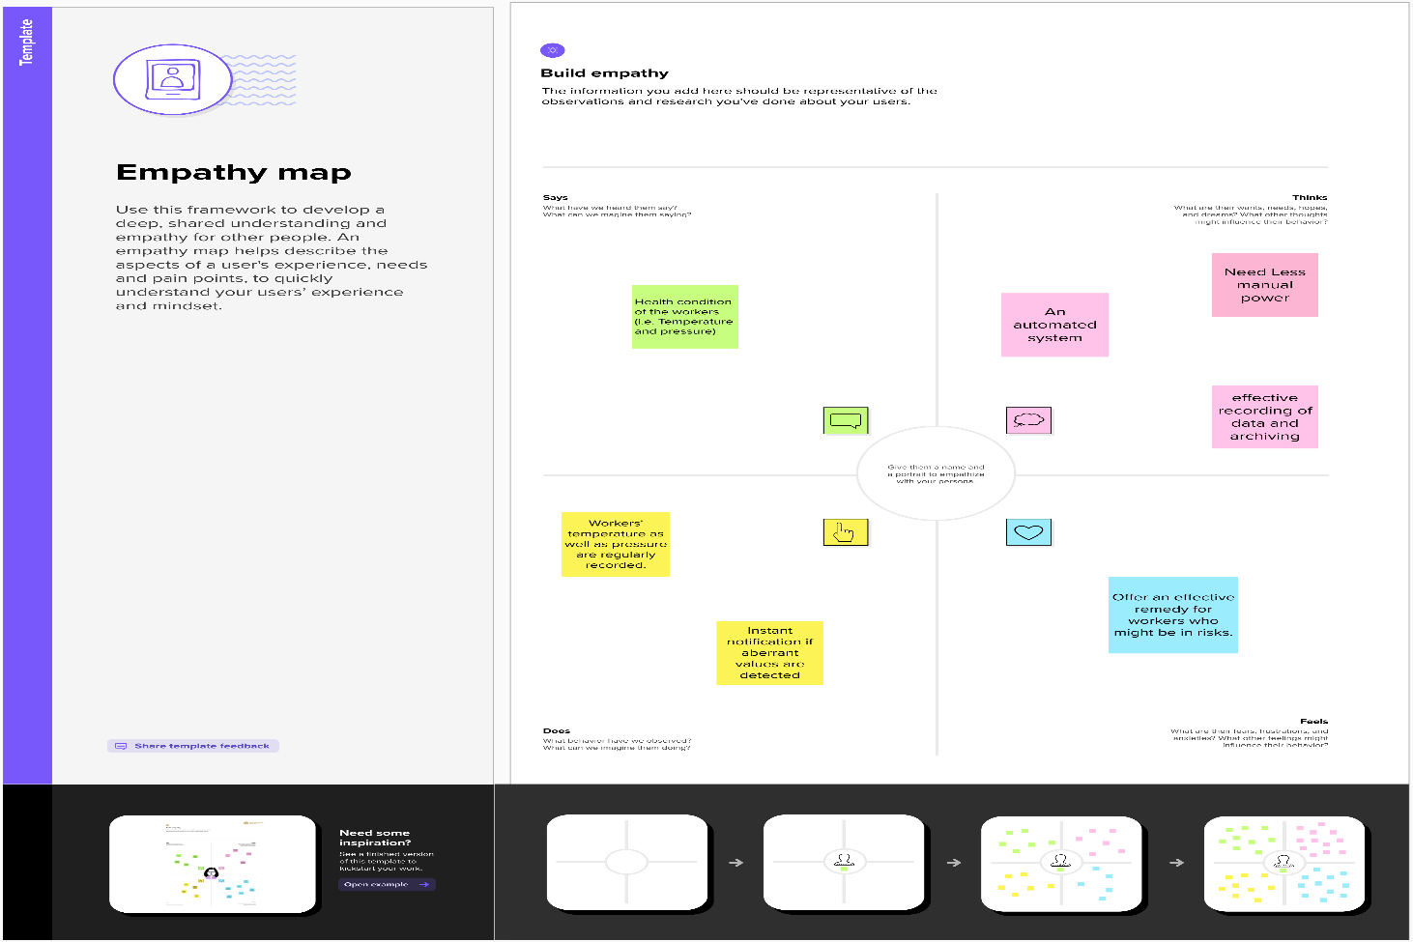

**2.3 Ideation & Brainstorming:**

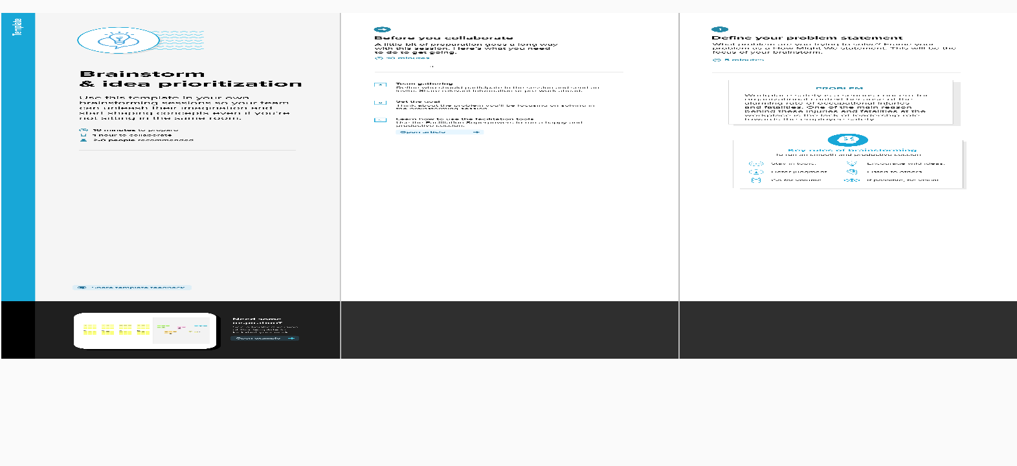

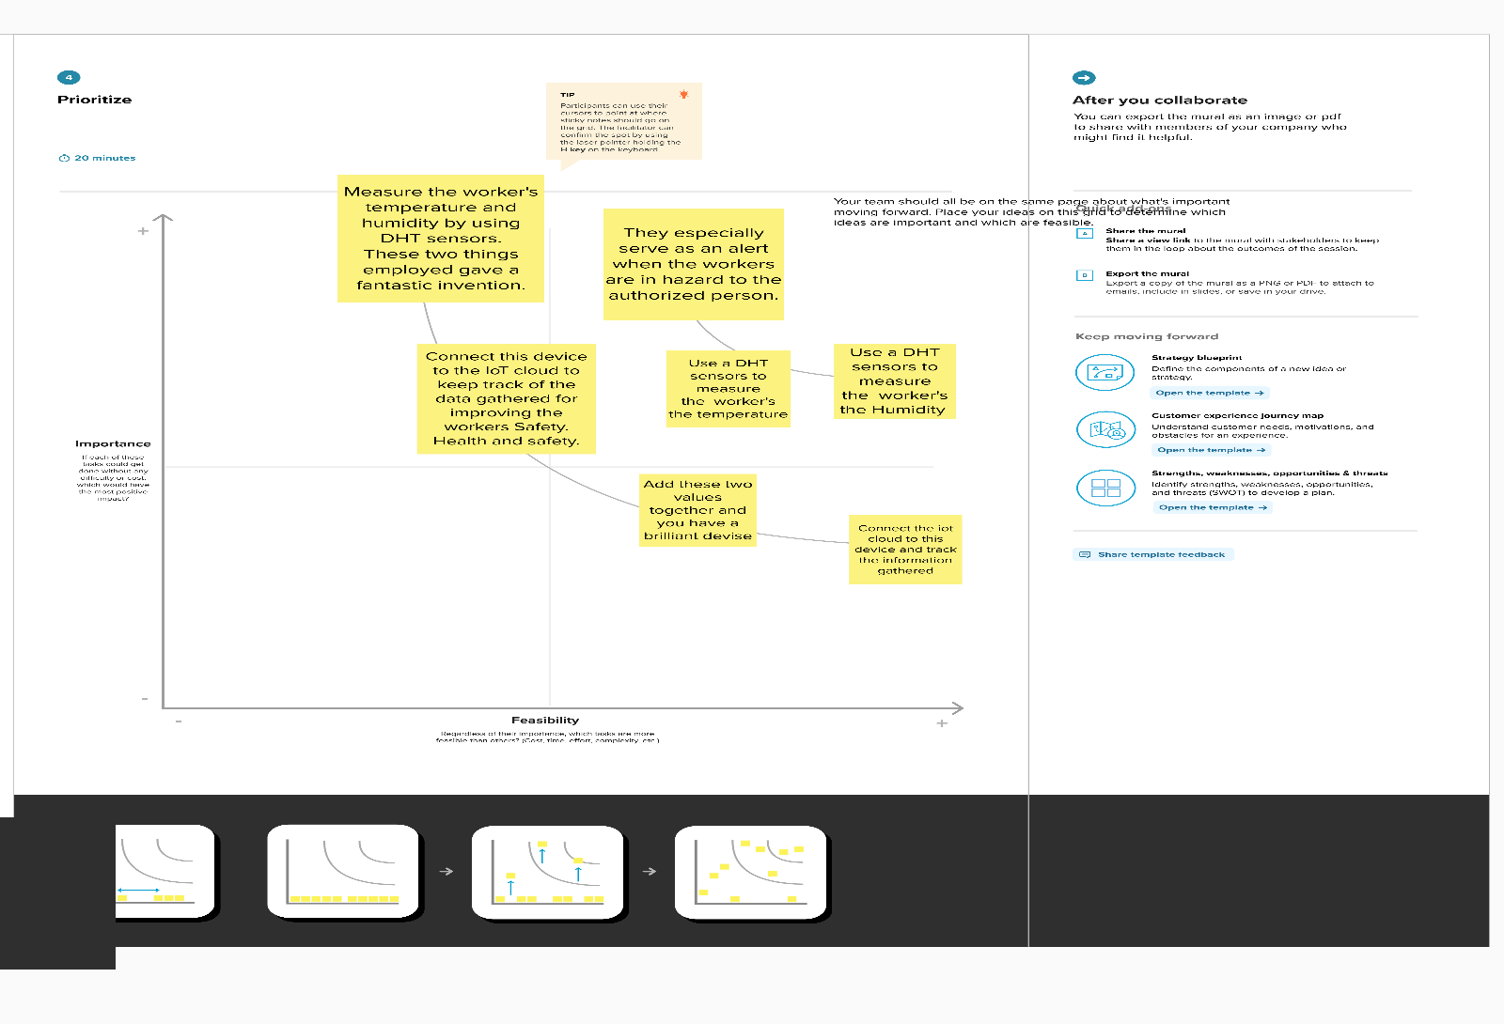

**2.4 Proposed Solution:**

The proposed solution for an Industrial Workers Health and Safety System based on the Internet of Things (IoT) aims to address the identified challenges and improve worker safety and well-being in industrial environments. The solution incorporates the following components Sensor Deployment, Wearable Devices, Data Analytics and Machine Learning, Real-time Alerts and Notifications, Emergency Response System, Data Visualization and Reporting, Integration with Existing Systems.By implementing this comprehensive IoT-based solution, industrial organizations can significantly enhance worker safety, proactively identify and mitigate risks, improve health monitoring, and streamline emergency response, ultimately creating a safer and healthier working environment.

**3. REQUIREMENT ANALYSIS:**

**Functional Requirements:**

Following are the functional requirements of the proposed solution.

|  |  |  |
| --- | --- | --- |
| **FR No.** | **Functional Requirement (Epic)** | **Sub Requirement (Story / Sub-Task)** |
| FR-1 | Measuring parameters | Measure the Temperature using DHT Sensor  Measure the Pressure  Count the Foot steps |
| FR-2 | Store the Information in the cloud | IBM Watson IOT platform |
| FR-3 | Cloud connected with web application | Node-Red |
| FR-4 | Monitoring and Alerting | Authorised person |

**Non-functional Requirements:**

Following are the non-functional requirements of the proposed solution.

|  |  |  |
| --- | --- | --- |
| NFR-1 | **Usability** | Real-time monitoring, Enhanced safety measures. |
| NFR-2 | **Security** | Device authentication, Data encryption, Access control |
| NFR-3 | **Reliability** | Redundancy and fault tolerance, Reliable connectivity, Continuous monitoring and maintenance, Testing and validation |
| NFR-4 | **Performance** | Data collection and processing speed, Low latency, Scalability |
| NFR-5 | **Availability** | Service level agreements (SLAs), Regular maintenance and updates, Monitoring and alerting |
| NFR-6 | **Scalability** | Distributed processing, Data storage scalability, Elasticity, Load testing and performance optimization |

**4. PROJECT DESIGN:**

**4.1 Data Flow Diagrams:**

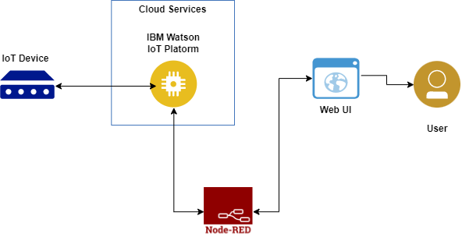

**4.2 Solution & Technical Architecture:**

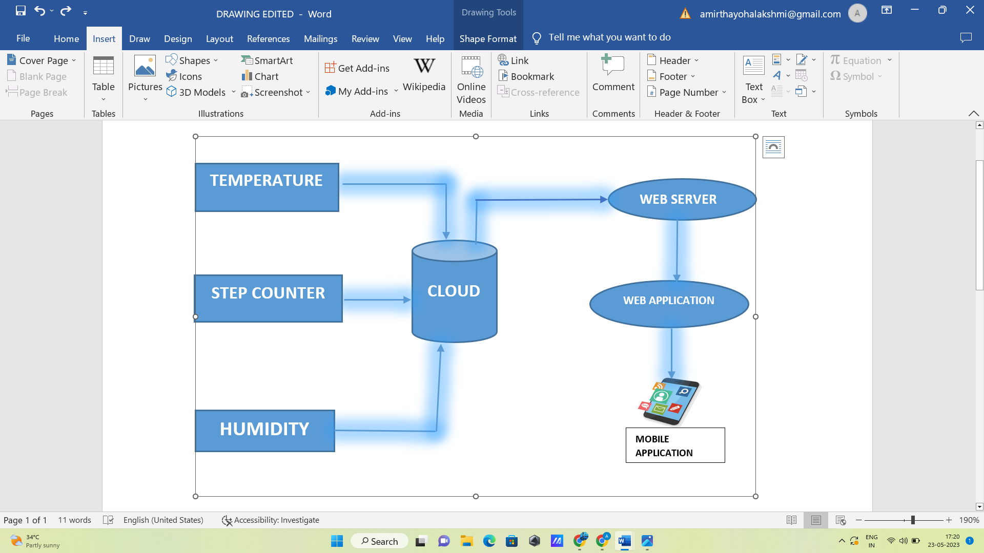

| **User Type** | **Functional Requirement (Epic)** | **User Story Number** | **User Story / Task** | **Acceptance criteria** | **Priority** | **Team Member** |
| --- | --- | --- | --- | --- | --- | --- |
| supervisor | receive real-time notifications | USN-1 | As a supervisor, I want to receive real-time notifications on my mobile device when a worker enters a hazardous area, so that I can ensure their safety and respond promptly in case of emergencies. | I can to receive real-time notifications on my mobile | High | Vidhya Bharathi |
| worker | connected wearable device | USN-2 | As a worker, I want to wear a connected wearable device that monitors my vital signs, such as heart rate and body temperature, and alerts me if they reach critical levels, ensuring my health and safety on the job. | I can wear a connected wearable device | High | Harshitha |
| safety officer | monitor | USN-3 | As a safety officer, I want to be able to remotely monitor the environmental conditions in the workplace, such as air quality and temperature, using IoT sensors | I can be able to remotely monitor the environment | Low | Harshitha |
| worker | Analyze data | USN-4 | As a manager, I want to analyze historical data collected by IoT sensors to identify trends and patterns in workplace incidents, helping me make informed decisions about safety protocols and training programs to minimize risks. | I can analyze historical data | Medium | Kalai Selvi |
| safety inspector | regular inspections | USN-5 | As a safety inspector, I want to conduct regular inspections using IoT-enabled devices to automatically capture and document safety-related information, reducing manual paperwork and streamlining the inspection process. | I can conduct regular inspections using IoT | High | Vidhya Bharathi |

**5. CODING & SOLUTIONING (Explain the features added in the project along with code):**

**5.1 Feature 1:**

Remote Health Monitoring and Alerts: The system allows for remote monitoring of worker health parameters and generates alerts when abnormal readings or health issues are detected. This feature enables supervisors or safety personnel to continuously monitor the well-being of workers from a centralized location, even if they are not physically present at the worksite. Wearable sensors: Workers wear IoT-enabled devices equipped with sensors to monitor their vital signs, body temperature, heart rate, or other relevant health metrics. Data transmission: The sensors continuously collect health data and transmit it wirelessly to a central monitoring system or cloud-based platform. Remote monitoring: The central monitoring system analyses the received data in real-time, comparing it against predefined thresholds or established health norms. Abnormality detection: If any worker's health parameters deviate from the normal range or exceed safety thresholds, the system identifies the anomaly as a potential health issue.

**5.2 Feature 2:** Alert generation: Upon detecting an abnormality, the system generates alerts and notifications, which can be sent to designated personnel, supervisors, or safety teams. These alerts can be in the form of text messages, emails, or even automated phone calls, depending on the severity of the situation. Prompt response: The alerted personnel can take immediate action, such as contacting the affected worker, dispatching medical assistance, or initiating emergency protocols, as necessary. Historical data tracking: The system can also store and analyse historical health data of workers, allowing for trend analysis, identification of recurring issues, or long-term health assessment. The remote health monitoring and alerts feature offers several benefits, including early detection of health problems, prompt intervention, and the ability to monitor multiple workers simultaneously. By leveraging IoT technology, this feature enhances worker safety, minimizes response time during emergencies, and ensures a proactive approach to safeguarding the health and well-being of industrial workers.

**6. RESULTS:**

**6.1 Performance Metrics:**

|  |  |  |
| --- | --- | --- |
| **Parameter** | **Values** | **Screenshot** |
| Metrics | Wowki Execution time and Output screenshot  Or  Python accuracy of prediction and output screenshot |  |

**7. ADVANTAGES & DISADVANTAGES:**

**Advantages of an industrial worker safety and health monitoring system using IoT:**

Enhanced Safety: IoT-based monitoring systems provide real-time data on worker health and safety parameters, allowing for proactive measures to prevent accidents and injuries. It enables timely response during emergencies, reducing the risk of severe consequences. Early Detection of Hazards: Continuous monitoring of environmental conditions and worker vitals enables the system to detect potential hazards or unsafe conditions promptly. This early detection helps in implementing preventive measures to mitigate risks. Remote Monitoring: IoT allows for remote monitoring of worker health and safety, enabling supervisors or safety personnel to monitor multiple workers simultaneously from a centralized location. It saves time, reduces costs, and improves overall efficiency. Improved Response Time: With instant alerts and notifications, the system enables rapid response to critical situations. Emergency personnel can be promptly dispatched, minimizing response time and potentially saving lives. Data-Driven Insights: The system collects and analyses large amounts of data, providing valuable insights into workplace safety trends, areas of improvement, and training needs. It facilitates evidence-based decision-making for enhancing safety protocols. Worker Empowerment: By providing workers with wearable devices and real-time feedback, IoT monitoring systems empower employees to take charge of their own safety. They become more aware of their health and well-being, leading to improved safety practices and a safer work environment**.**

**Disadvantages of an industrial worker safety and health monitoring system using IoT:**

Data Privacy and Security Risks: IoT systems involve the collection and transmission of sensitive data, raising concerns about data privacy and security. Unauthorized access or breaches can lead to privacy violations or potential misuse of personal health information. Reliance on Technology: IoT systems are dependent on technology infrastructure, such as wireless networks and cloud platforms. System failures, network outages, or cybersecurity incidents can disrupt monitoring capabilities and compromise worker safety. Implementation and Maintenance Costs: Implementing an IoT monitoring system requires significant upfront investments in hardware, software, connectivity, and personnel training. Additionally, ongoing maintenance and updates add to the overall costs. Data Overload and Interpretation: IoT systems generate vast amounts of data that need to be processed and analysed effectively. Handling and interpreting such large volumes of data can be challenging, requiring robust data analytics capabilities. User Acceptance and Training: Introducing IoT technology and wearable devices to workers may face resistance or require training to ensure proper usage. User acceptance and adoption are crucial for the system's success. Potential False Alarms: IoT sensors may occasionally generate false alarms or inaccurate readings, leading to unnecessary alerts and potentially undermining trust in the system. Regular calibration and maintenance are necessary to minimize such occurrences.

**8. CONCLUSION:**

In conclusion, implementing an industrial worker safety and health monitoring system using IoT offers significant advantages in enhancing workplace safety and protecting the well-being of employees. By leveraging IoT technology, wearable sensors, and real-time data analysis, these systems provide a comprehensive approach to worker safety management. The benefits of such systems include enhanced safety through early detection of hazards, remote monitoring capabilities, and improved response time during emergencies. The ability to continuously monitor worker health parameters and environmental conditions allows for proactive measures and timely intervention, minimizing the risk of accidents and injuries. Moreover, IoT-based monitoring systems provide valuable data-driven insights, enabling evidence-based decision-making for safety protocols, training programs, and overall risk management. This data-driven approach facilitates ongoing improvement and helps create a culture of safety within the organization. However, it is important to address potential challenges and risks associated with data privacy, security, implementation costs, and user acceptance. Adequate measures should be in place to protect sensitive data, ensure the reliability of the system, and provide proper training to workers to maximize user acceptance and adoption. Overall, an industrial worker safety and health monitoring system using IoT represents a significant step towards creating safer work environments. By leveraging technology, real-time monitoring, and data analytics, these systems enable organizations to prioritize worker safety, prevent accidents, and foster a culture of well-being. It is an investment that can yield substantial benefits in terms of improved safety outcomes, reduced costs, and enhanced productivity.

**9. FUTURE SCOPE:**

The future scope of the Industrial Workers Health and Safety System based on the Internet of Things (IoT). with several potential advancements and developments on the horizon. Here are some areas of future scope for these systems. **Advanced Sensor Technology**: The development of more advanced and miniaturized sensors can lead to the integration of additional health monitoring capabilities into wearable devices. For example, sensors that can detect specific chemical exposures or monitor fatigue levels with higher precision could enhance the system's ability to identify and mitigate potential risks. **Artificial Intelligence and Machine Learning:** The integration of AI and machine learning algorithms can enable more sophisticated data analysis and pattern recognition. These technologies can help identify complex relationships between various health and safety parameters, allowing for more accurate risk assessments and predictive analytics.**Predictive Analytics**: By leveraging historical data and machine learning algorithms, IoT monitoring systems can move beyond real-time monitoring to predict potential safety hazards and health risks. This proactive approach can help organizations implement preventive measures and interventions before accidents or injuries occur. **Integration with Smart PPE**: The integration of IoT capabilities into personal protective equipment (PPE) can provide real-time monitoring of vital signs, environmental conditions, and other safety parameters directly from the equipment itself. This integration enhances worker comfort and safety while streamlining data collection.

**Augmented Reality (AR) and Virtual Reality (VR):** AR and VR technologies can be incorporated into IoT monitoring systems to provide workers with real-time safety information, interactive training simulations, and virtual guidance. These immersive technologies can enhance worker awareness, improve training effectiveness, and further reduce the risk of accidents. **Blockchain for Data Security**: The implementation of blockchain technology can enhance data security and privacy in IoT monitoring systems. By utilizing distributed ledger technology, it becomes more challenging for unauthorized parties to tamper with or access sensitive health and safety data. **Integration with EHS Management Systems:** IoT monitoring systems can be seamlessly integrated with existing Environmental, Health, and Safety (EHS) management systems. This integration enables comprehensive safety management by consolidating data, streamlining reporting processes, and facilitating compliance with regulatory requirements.**Wearable Robotics and Exoskeletons:** IoT monitoring systems can be combined with wearable robotics and exoskeleton technologies to enhance worker safety and reduce physical strain. These devices can provide real-time feedback and support to workers, preventing musculoskeletal injuries and improving ergonomics.**Cloud-Based Analytics and Collaboration:** Moving towards cloud-based analytics and collaboration platforms can enable real-time data sharing, remote access, and collaboration among different stakeholders. This enhances communication, coordination, and decision-making for safety management across geographically dispersed locations.**Integration with IoT Ecosystems:** IoT monitoring systems can be integrated into broader IoT ecosystems within industrial environments. This integration allows for seamless data exchange between different IoT devices and systems, enabling comprehensive monitoring, control, and automation for enhanced safety and operational efficiency. As technology continues to advance, the future scope of industrial worker safety and health monitoring systems using IoT holds immense potential for further improving workplace safety, reducing incidents, and promoting the well-being of workers.

**10. APPENDIX:**

#include &lt;WiFi.h&gt;//library for wifi

#include &lt;PubSubClient.h&gt;//library for MQtt

#include &quot;DHT.h&quot;// Library for dht11

#define DHTPIN 4 // what pin we&#39;re connected to

#define DHTTYPE DHT11 // define type of sensor DHT 11

//#define LED 5

DHT dht (DHTPIN, DHTTYPE);// creating the instance by passing pin and typr of dht connected

void callback(char* subscribetopic, byte* payload, unsigned int payloadLength);

//-------credentials of IBM Accounts------

#define ORG &quot;96ei56&quot;//IBM ORGANITION ID

#define DEVICE_TYPE &quot;worker&quot;//Device type mentioned in ibm watson IOT Platform

#define DEVICE_ID &quot;0104&quot;//Device ID mentioned in ibm watson IOT Platform

#define TOKEN &quot;04012023&quot; //Token

String data3;

float t;

int p;

//-------- Customise the above values --------

char server[] = ORG &quot;.messaging.internetofthings.ibmcloud.com&quot;;// Server Name

char publishTopic[] = &quot;iot-2/evt/Data/fmt/json&quot;;// topic name and type of event perform and format

in which data to be send

char subscribetopic[] = &quot;iot-2/cmd/test/fmt/String&quot;;// cmd REPRESENT command type AND

COMMAND IS TEST OF FORMAT STRING

char authMethod[] = &quot;use-token-auth&quot;;// authentication method

char token[] = TOKEN;

char clientId[] = &quot;d:&quot; ORG &quot;:&quot; DEVICE_TYPE &quot;:&quot; DEVICE_ID;//client id

//-----------------------------------------

WiFiClient wifiClient; // creating the instance for wificlient

PubSubClient client(server, 1883, callback ,wifiClient); //calling the predefined client id by passing

parameter like server id,portand wificredential

void setup()// configureing the ESP32

{

Serial.begin(115200);

dht.begin();

//pinMode(LED,OUTPUT);

delay(10);

Serial.println();

wificonnect();

mqttconnect();

}

void loop()// Recursive Function

{

//h = dht.readHumidity();

p= random(60,150);

t = dht.readTemperature();

Serial.print(&quot;temperature:&quot;);

Serial.println(t);

Serial.print(&quot;Pulse:&quot;);

Serial.println(p);

PublishData(t, p);

delay(1000);

if (!client.loop()) {

mqttconnect();

}

}

/*.....................................retrieving to Cloud...............................*/

void PublishData(float temp, int pulse) {

mqttconnect();//function call for connecting to ibm

/*

creating the String in in form JSon to update the data to ibm cloud

*/

String payload = &quot;{\&quot;temperature\&quot;:&quot;;

payload += temp;

payload += &quot;,&quot; &quot;\&quot;Pulse\&quot;:&quot;;

payload += pulse;

payload += &quot;}&quot;;

Serial.print(&quot;Sending payload: &quot;);

Serial.println(payload);

if (client.publish(publishTopic, (char*) payload.c_str())) {

Serial.println(&quot;Publish ok&quot;);// if it sucessfully upload data on the cloud then it will print publish ok

in Serial monitor or else it will print publish failed

} else {

Serial.println(&quot;Publish failed&quot;);

}

}

void mqttconnect() {

if (!client.connected()) {

Serial.print(&quot;Reconnecting client to &quot;);

Serial.println(server);

while (!!!client.connect(clientId, authMethod, token)) {

Serial.print(&quot;.&quot;);

delay(500);

}

initManagedDevice();

Serial.println();

}

}

void wificonnect() //function defination for wificonnect

{

Serial.println();

Serial.print(&quot;Connecting to &quot;);

WiFi.begin(&quot;Wokwi-GUEST&quot;, &quot;&quot;, 6);//passing the wifi credentials to establish the connection

while (WiFi.status() != WL_CONNECTED) {

delay(500);

Serial.print(&quot;.&quot;);

}

Serial.println(&quot;&quot;);

Serial.println(&quot;WiFi connected&quot;);

Serial.println(&quot;IP address: &quot;);

Serial.println(WiFi.localIP());

}

void initManagedDevice() {

if (client.subscribe(subscribetopic)) {

Serial.println((subscribetopic));

Serial.println(&quot;subscribe to cmd OK&quot;);

} else {

Serial.println(&quot;subscribe to cmd FAILED&quot;);

}

}

void callback(char* subscribetopic, byte* payload, unsigned int payloadLength)

{

Serial.print(&quot;callback invoked for topic: &quot;);

Serial.println(subscribetopic);

for (int i = 0; i &lt; payloadLength; i++) {

//Serial.print((char)payload[i]);

data3 += (char)payload[i];

}

Serial.println(&quot;data: &quot;+ data3);

data3=&quot;&quot;;

}

Wokwi link

https://wokwi.com/projects/365240425567309825

**Demo link:**

**https://drive.google.com/file/d/13KQJ0C8D8dDmMn9yk8VH7F5k7bxUxzLF/view?usp=drivesdk**